Education Toolbox
Glove Use in Clinical Care

Introduction
Gloves are not required for all care activities. They should only be worn during clinical care (clinical procedures or care activities) where risk presents. Understanding when gloves are required, the types of gloves available, and their limitations supports safe and effective care.

1. Why are gloves worn?
- To protect against exposure to blood and other body fluids
- To reduce exposure risk to hazardous substances and chemicals
- To help reduce risk of contamination to self, others, equipment and the environment
- Sterile gloves are used to reduce the risk of contamination of sterilised items during aseptic technique procedures

2. Facts about glove use
- Gloves are not a substitute for hand hygiene.
- In some situations, hand hygiene alone may be safer and more appropriate than wearing gloves.
- Cuts, abrasions, or broken skin on hands should be covered with an occlusive dressing before gloves are worn.
- Gloves may have microscopic defects and do not provide absolute protection from hand contamination.
- Gloves can become contaminated during use and may spread microorganisms if not changed appropriately.
- Hands can become contaminated during glove removal if correct technique is not followed.
- Gloves are single-use items and must never be washed, sanitised or reused.

3. Types of gloves used in clinical care
Gloves used in clinical care are defined as single-use, disposable gloves. These include:
- Non-sterile, non-powdered examination or medical gloves:
  - Nitrile – recommended safest for use
  - Latex – Allergy risks: should only be used when no safer alternative exists. Allergy risks must be identified, assessed and managed. Not recommended for use with chemicals.
- Sterile surgical gloves with specific characteristics of thickness, elasticity, strength
  - Latex
  - Nitrile
  - Polyisoprene
  - Neoprene

Note: Vinyl gloves are not recommended for use in clinical care or with chemicals

Examples:
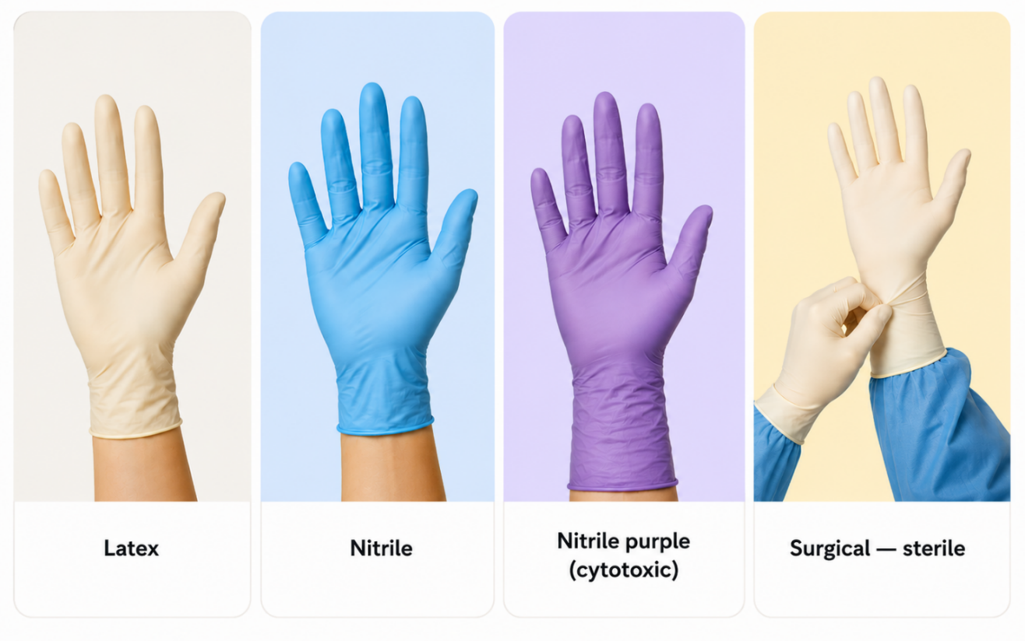

4. When TO wear gloves
Exposure type | Example
Direct Care | Nitrile or Latex:  Note: those with latex allergies must always wear latex-free gloves  - Where the resident or client skin is NOT intact (eczema, or cracked or dry skin)  - During activities that may involve exposure to blood and body fluids (excluding sweat) including contact with mucous membranes (respiratory/nasal passages, digestive tract, urogenital tract, eyes and ears).  - When in contact with used, contaminated or soiled items, surfaces or equipment (used linen, bed pan/urinals and medical or non-medical equipment).  - When handling used equipment, blood, body fluid or non-chemical spills  Nitrile gloves:  - When providing care for all residents/clients requiring transmission-based precautions.  - When handling suspected or confirmed infectious equipment/items  - When handling or using chemicals  - When attending infectious cleaning/blood and body fluid spills  Nitrile gloves – cytotoxic: (purple is the industry standard, but not mandatory)  - During activities that involve exposure to blood and body fluids of resident/client r on cytotoxic medications  - When in contact with cytotoxic contaminated items (e.g. waste, linen contaminated with blood/body fluids, used bed pan/urinals, incontinence aids, med cups/equipment)  Sterile gloves; (Latex, Nitrile, Polyisoprene, Neoprene)  - For clinical procedures where aseptic technique is required (e.g. sterile wound care and invasive device insertion).

5. When NOT to wear gloves
Exception: when required for transmission-based precautions or if blood or body fluids exposure is anticipated.
Exposure type | Example
Direct Care | - Taking observations, i.e. temperature, pulse, BP  - Administering SC and IM injections  - Applying non-invasive ventilation or oxygen equipment  - Providing care (bathing, dressing, feeding, tidying/bed making) where there is no contact with blood or body fluids, mucosa, non-intact skin  - Assisting with mobilisation or transporting a resident/client
Indirect Care | - Using the telephone  - Completing documentation  - Preparing and administering oral medication (unless cytotoxic/harmful)  - Making a bed (unless soiled), tidying room or moving furniture or other items  - Distributing or collecting meals or meal trays

Decision Tool: The Glove Pyramid –when to wear (and not wear) gloves

6. When to change gloves in care
- Gloves must be removed or if necessary, changed after each task/activity, when contaminated or if they become damaged. Such as:
- After contact with blood or body fluid, mucous membranes or non-intact skin
- When moving from one body site to another on the same individual
- When providing care to one individual and then moving onto another individual
- After each care task is completed
- When damaged
- When hands become excessively moist or sweaty

7. Overuse
Overuse of gloves can result in
- Missed hand hygiene opportunities
- Increase risk of skin irritation or dermatitis
- Wasted resources
- Negative impact on sustainability
- Raise costs including price of products and waste removal
- Cause an environment impact

8. Hand Hygiene
- Hand hygiene must be performed:
  - Before putting on gloves (donning)
  - Immediately after removing gloves (doffing)
  - When indicated as per the 5 Moments for Hand Hygiene

9. Gloving
- Appropriate glove selection and correct donning and doffing techniques minimise the risk of cross-transmission.
  - 5 Easy Steps for Gloving Use https://www.safetyandquality.gov.au/sites/default/files/2026-04/5-easy-steps-glove-use-poster-a3.PDF
  - Appendix 1 - Technique for donning and removing non-sterile examination gloves

10. References
- Australian Commission on Safety and Quality in Health Care. The aged care infection prevention and control guide. Sydney: ACSQHC; 2024. Available from: https://www.safetyandquality.gov.au/sites/default/files/resources/attachments//The-Aged-Care-Infection-Prevention-and-Control-Guide.pdf
- National Health and Medical Research Council, Australian Commission on Safety and Quality in Health Care. Australian guidelines for the prevention and control of infection in healthcare. Canberra: NHMRC; 2019. Available from: https://www.safetyandquality.gov.au/sites/default/files/2026-05/australian-guidelines-for-the-prevention-and-control-of-infection-in-healthcare.pdf
- Australian Commission on Safety and Quality in Health Care. Sustainable glove use for healthcare workers. Sydney: ACSQHC; 2024. Available from: https://www.safetyandquality.gov.au/resources/sustainable-glove-use-healthcare-workers-fact-sheet
- Peters S, Lim L, Francis JJ, Bennett N. Analysis of infection prevention and control documentation in residential aged care based on a behaviour specification framework. Infect Dis Health. 2025. doi:10.1016/j.idh.2025.03.002.
- Australia. Work Health and Safety Regulations 2011. Canberra (ACT): Federal Register of Legislation; 2011. Available from: https://www.legislation.gov.au/F2011L02664/2021-08-11/text
- World Health Organization. Glove use information leaflet. Geneva: World Health Organization; 2009. Available from: https://www.who.int/publications/m/item/glove-use-information-leaflet-(revised-august-2009)

11. Endorsement / Approval
Version | Date | Addition/Amendments | Author | Review By
1.0 | August 2026 | New Resource | C Spinks and ACIPC Aged Care Working Group | Advancing IPC Practice and Standards Committee

12. Contact Information
ACIPC office: office@acipc.org.au

Appendix 1
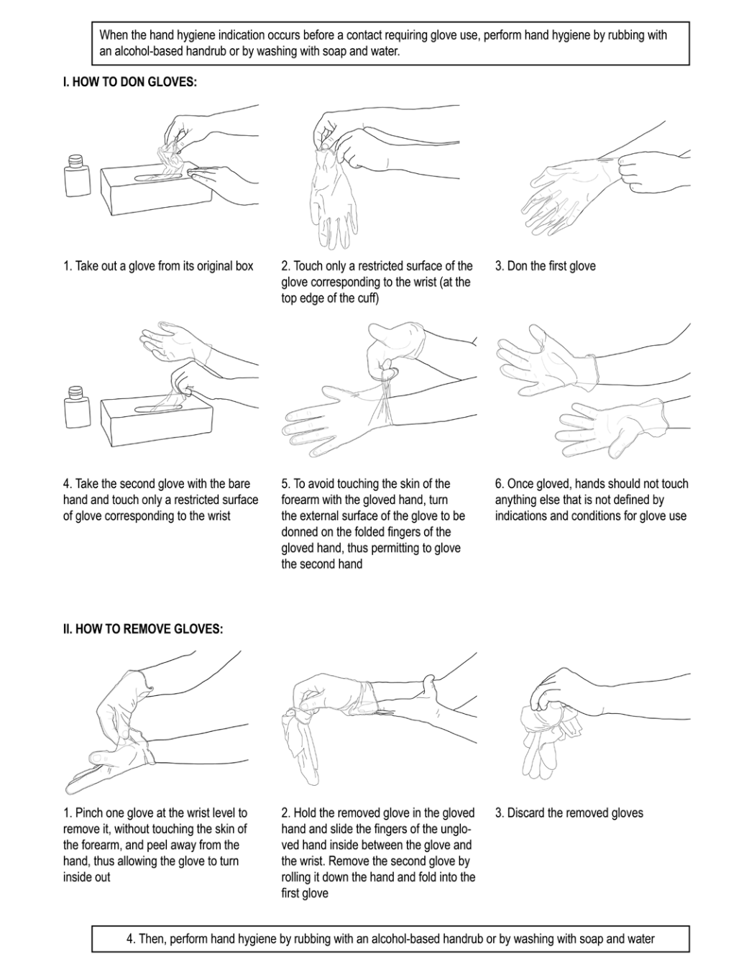
Technique for donning and removing non-sterile examination gloves: https://cdn.who.int/media/docs/default-source/integrated-health-services-(ihs)/infection-prevention-and-control/hand-hygiene/tools/glove-use-information-leaflet.pdf?sfvrsn=13670aa_10&download=true

