Reprocessing of Reusable Equipment in Aged Care Guide
Reprocessing of medical equipment in aged care is crucial for infection prevention and resident safety.

1. Key points include:
- Reprocessing level depends on infection risk based on item use.
- Most reusable equipment in aged care is non-critical.
- Critical and semi-critical items are typically disposable.
- Reprocess after each use and on a routine schedule.
- Follow manufacturer's instructions for compatibility and methods.
- Visually inspect equipment for cleanliness and functionality before storage or use.

2. Best practices
- Train health care workers (HCW) involved in reprocessing.
- Establish a routine cleaning schedule.
- Use appropriate personal protective equipment.
- Maintain documentation for quality assurance – as appropriate.

3. Template
Heat and chemical:
Sanitizer – For bedpan and urinal use only., Heat (hot water) sanitization only.  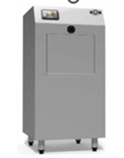 | Disinfectors Washer -For all reusable items: bedpans, urinals, tooth mugs, bowls. Heat (hot water) and detergent sanitization.  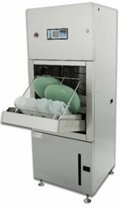
Cold chemical:
Cleaning frequency may increase during outbreak
Reusable shared Equipment | Frequency | Procedure
Shower chair  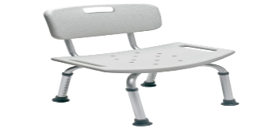  This Photo by Unknown Author is licensed under CC BY-NC | After each use, and daily  (weekly if single user) | - Use detergent wipes/disinfectant wipes  - Wipe base and back of chair  - Wipe underside of seat  - Wipe chair legs  Include in routine cleaning schedule.
Bedpans, urinals, urine jug  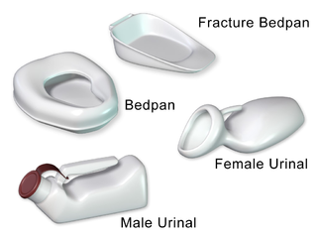 | After each use | - Bedpans and urinals clean and soiled must be covered with a paper cover when being transported  - Contents of the bedpan or urinal must be emptied into the toilet at the point of care and not transported through the home  - Place bedpan/commode pan/urinal directly into the disinfectant washer after use.  - Used items should not be stacked and left on the top of the disinfectant washer
Observation machine and Blood Pressure Cuff  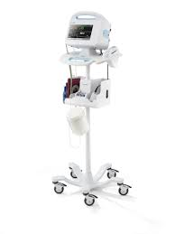 | After each use | - Check manufacturer’s instruction.  - Use detergent wipes/disinfectant wipes  - Wipe over all parts of the machine and cuff  Include in routine cleaning schedule.
Bowls Washing   | After each use | - Use Washer Disinfector  - Where there is no machine:  - HCW to wear PPE -apron and gloves  - Clean bowl with warm water and detergent after each use and rinse.  - Store bowls separately and inverted to reduce contamination
Commodes  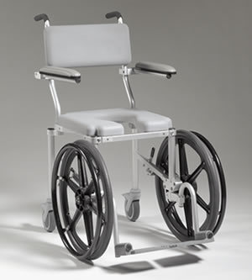  This Photo by Unknown Author is licensed under CC BY-ND | After each use,  and daily | - Use detergent wipes/disinfectant wipes  - Wipe base and back and armrests of chair  - Wipe underside of seat Wipe chair wheels and foot plates  - Ensure, pan is clean post use  Include in routine cleaning schedule.
Glucometer  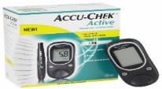  This Photo by Unknown Author is licensed under CC BY-NC-ND | After each use | - Ideally older person has their own device  - Use detergent wipes/disinfectant wipes  - Check manufacturer’s instruction.  - Thoroughly wipe over all parts
Hoists  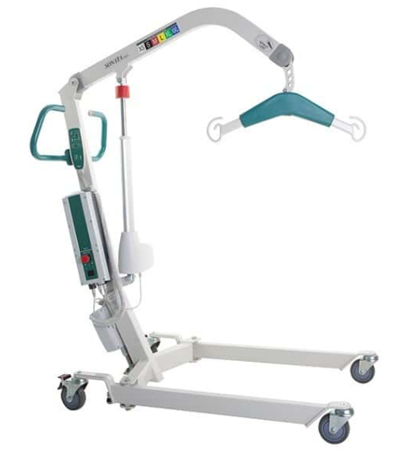 | After each use and daily | - Use detergent wipes/disinfectant wipes  - Wipe over the frames  - Wipe handlebars and grips  - Wipe base and wheels  - Wipe controls  Include in routine cleaning schedule.
Slings  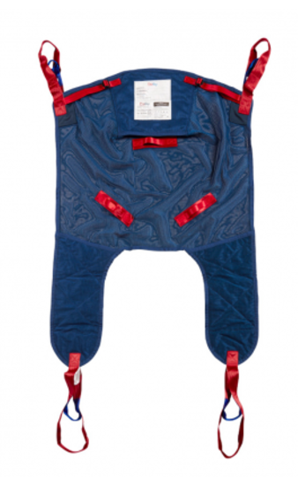 | Monthly and as required (or as manufacturer’s instructions) | - As possible: dedicate sling to client  - All slings are numbered and weekly washed in accordance with their number  - Care HCW send the slings to the laundry on the allocated day of washing  - Laundry HCW mark that they have washed according to the sling number- that is on their monthly list  - Use manufacturer washing instructions
Walking Frames  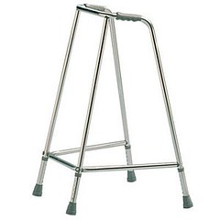 | After each use and daily  (weekly if single user) | - Use detergent wipes/disinfectant wipes  - Wipe over all parts of the frames including handles and legs  Include in routine cleaning schedule.
Wheelchairs  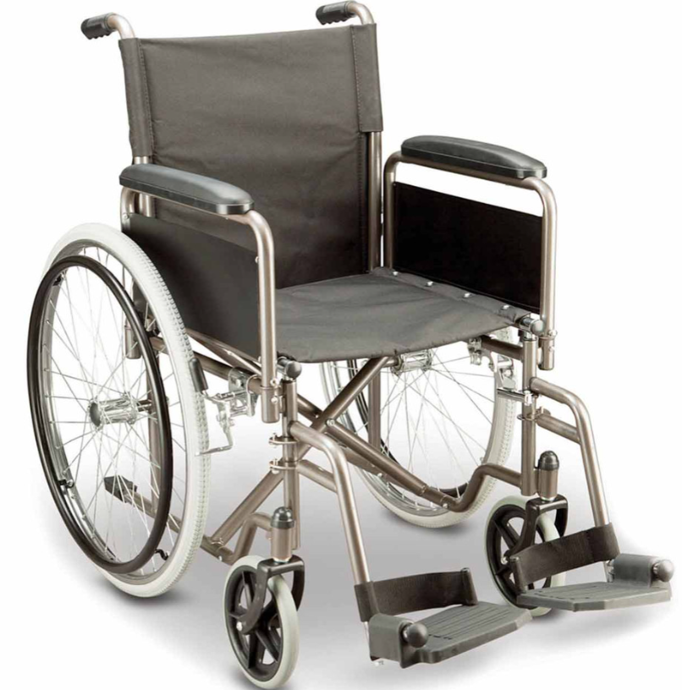 | After each use and daily  (weekly if single user) | - Use detergent wipes/disinfectant wipes  - Wipe base and back of chair  - Wipe underside of seat  - Wipe handle grips  - Wipe wheels and foot plates  Include in routine cleaning schedule
Weigh Chairs  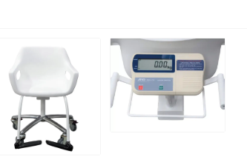 | After each use and daily | - Use detergent wipes/disinfectant wipes  - Wipe base and back of chair  - Wipe underside of seat and bars  - Wipe handle grips  - Wipe wheels and foot plates  Include in routine cleaning schedule
Syringe driver  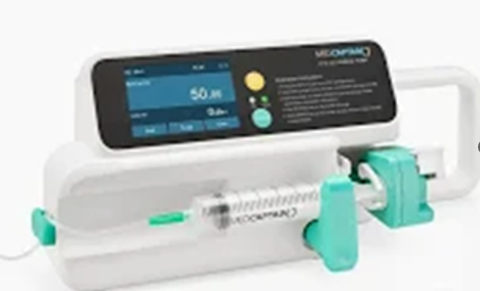 | Daily when in use | - Use detergent wipes/disinfectant wipes  - Wipe over all surfaces and buttons  - Wipe over any cords  - Check the syringe driver as per instructions in the kit  Include in routine cleaning schedule
General equipment | Frequency | Procedure
Linen skip frames  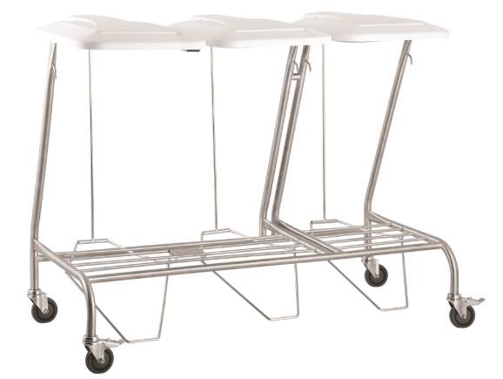 | After use and daily | - Use detergent wipes/disinfectant wipes  - Wipe the lid  - Wipe the entire frame  - Wipe the base and wheels  Include in routine cleaning schedule.
Medication Trolley  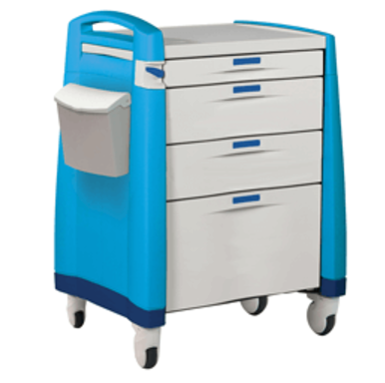 | After use and daily | - Use detergent wipes/disinfectant wipes  - Wipe over all external surfaces  - Take items out of draws and wipe inside draws and compartments  - Wipe over wheels  - Ensure there is wipes and hand gel on the trolley  Include in routine cleaning schedule.
Dressing trolley  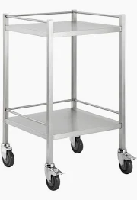 | Before and after use | - Use disinfectant wipes  - Wipe over top and bottom platform  - Wipe frame around platforms  - Wipe trolley legs  - Wipe wheels  Remove draws  No items to be stored on the bottom shelf
Medication / Specimen fridges  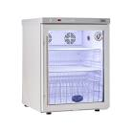 | Monthly | - Use detergent wipes/disinfectant wipes  - Remove all items out of fridge – discard any out-of-date items  - Wipe all racks and shelves  - Wipe containers  - Wipe internal walls, ceiling and floor  - Wipe external walls top and door  - Defrost the freezer and manage if required  Include in routine cleaning schedule.
Tech equipment | Frequency | Procedure
Desk and computers on wheels laptops and keyboards  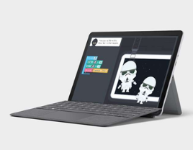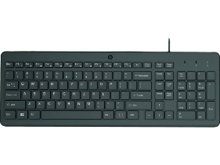 | After use | - Use detergent wipes/disinfectant wipes  - Wipe over all surfaces and buttons  - Wipe over any cords and attachment  - Check the device cleaning instructions
Printer  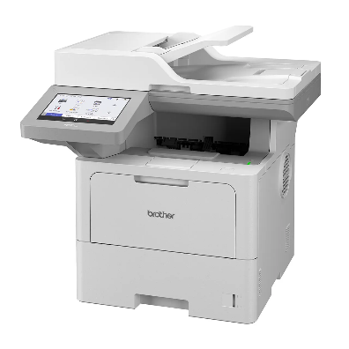 | After use and full weekly | - Use detergent wipes/disinfectant wipes  - Wipe over all surfaces and buttons  - Wipe over any cords and holders  - Check the device cleaning instructions  Include in routine cleaning schedule
Single user equipment | Frequency | Procedure
Nebulizers  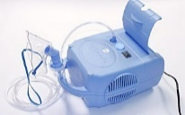 | After every use and daily | - Single older person use  - Use detergent wipes/disinfectant wipes  - Wipe over the entire surface  - Wipe under covers and in storage parts  - Wipe over tubing and mask  - Change tubing and mask weekly (or as manufacturer’s instructions)  - Include in cleaning schedule.
Concentrator and nasal prongs  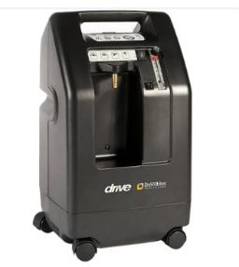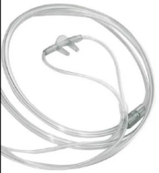 | After each use and full monthly | - Single older person use  - Use detergent wipes/disinfectant wipes  - Wipe over the entire surface  - Wipe under covers and in storage parts  - Wipe over tubing and prongs  - Change tubing and prongs weekly  Include in cleaning schedule.
CPAP  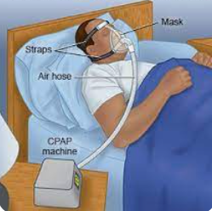 | After each use and full monthly | - Single older person use  - Use detergent wipes/disinfectant wipes  - CPAP Cleaning process (as per manufacturer’s instructions)  Include in cleaning schedule.
Denture cup and toothbrush holder  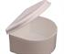 | After each use | - Single older person use  - HCW to wear precaution PPE -apron and gloves  - Clean mugs with warm water and detergent after each use, rinse  - Store in older person’s bathroom

4. References

- Australian Commission on Safety and Quality in Health Care. The aged care infection prevention and control guide [Internet]. Sydney: ACSQHC; 2024 [cited 2024 Nov 20]. Available from: https://www.safetyandquality.gov.au/sites/default/files/resources/attachments/The-Aged-Care-Infection-Prevention-and-Control-Guide.pdf
- National Health and Medical Research Council. Australian guidelines for the prevention and control of infection in health care [Internet]. Canberra: NHMRC; 2019 [cited 2024 Nov 20]. Available from: https://www.safetyandquality.gov.au/publications-and-resources/resource-library/australian-guidelines-prevention-and-control-infection-healthcare
- Standards Australia. AS 5369:2023 Reprocessing of reusable medical devices and other devices in health and non-health related facilities. Sydney: Standards Australia; 2023. Available from: https://www.standardsau.com/standards/as-5369-2023/

5. Endorsement / Approval
Version | Date | Addition/Amendments | Author | Review By
1.0 | June 2024 | New resource | C Spinks IPC CNC | Aged Care IPC CNC group
2.0 | Dec 2025 | Addition of non-medical equipment | C Spinks IPC CNC | Aged Care IPC CNC group, Terry McAuley (Medical Device Decontamination expert)
3.0 | Jun 2026 | Branded and format change | C Spinks IPC CNC | Aged Care working Group

6. Contact Information
ACIPC office: office@acipc.org.au

