Dry Surface Biofilm Research Group presents latest findings at Sydney Seminar
22nd November 2016
In October, an educational seminar was held in Melbourne to showcase the latest findings of the Dry Surface Biofilm (DSB) research group. This group is part of an Australian Research Council Linkage grant and is a collaboration between Macquarie University, Western Sydney University and Whiteley Medical.
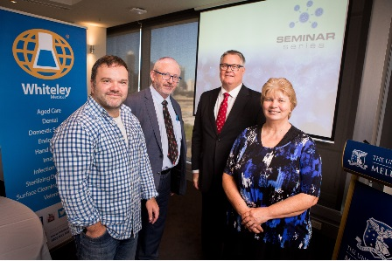
The keynote speakers at the event were Professor Iain Gosbell (School of Medicine, Western Sydney University), Associate Professor Karen Vickery (Surgical Infection Research Group, Department of Medicine and Health Sciences, Macquarie University), Associate Professor Slade Jensen (Infectious Diseases and Microbiology, School of Medicine, Western Sydney University) and Dr Greg Whiteley.
Global leaders in this field, they explained how bacteria reside in dry surface biofilms in the environment, the risk this poses to patients in healthcare, and the challenges to current infection prevention in healthcare.
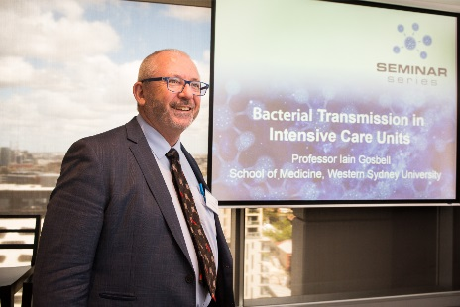
Professor Iain Gosbell presented on the transmission of pathogenic organisms in intensive care; Associate Professor Karen Vickery discussed biofilm location, characteristics and content in Intensive Care Unit (ICU); Associate Professor Slade Jensen focused on genetics similarities in organisms isolated from the ICU and Dr Greg Whiteley on Integrated Cleaning Monitoring in ICU. Biofilm may be a problem in the transmission of CRE, and a recent outbreak of CRE in Victoria made these presentations very timely.
The half day seminar was attended by a wide cross-section of healthcare professionals including academics, infection control managers, nurse unit managers, medical professionals and Scientific and Legal Professional personnel. Those attending the seminar were able to earn Continual Professional Development (CPD) points.
The seminar highlighted the many challenges this new research poses to conservative infection prevention in healthcare and indeed general microbiological thinking. Many bacteria that are typically thought of as planktonic (freely floating around) are actually protected in Biofilms in the environment. Bacteria in biofilms have recently been shown to resist heat, chlorine (a typical disinfectant used in hospitals) and other forms of disinfectants.
Novel approaches are required to address this newly found problem. The good news is that the research is continuing to look at ways to decrease Healthcare Acquired Infections resulting from Dry Surface Biofilms.

